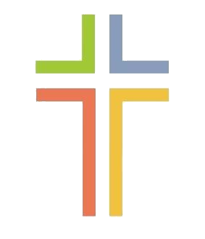
April

Sunday 26th 10:45am Morning Service + ignite

May
Sunday 3rd 10:45 am Morning Service + ignite

Sunday 10th 10:45 am All Age Worship

Sunday 17th 10:45 am Communion Service
+ ignite

Sunday 24th 10:45 am Café Church

Sunday 31st 10:45 am Morning Service + ignite

